Three Vents

Three vents connected to an Arduino board through three SSR’s (Solid State Relay). A 3D accelerometer is also connected to the Arduino board and placed on a balance board. The vent in which direction the person on the balance board leans, is turned on.

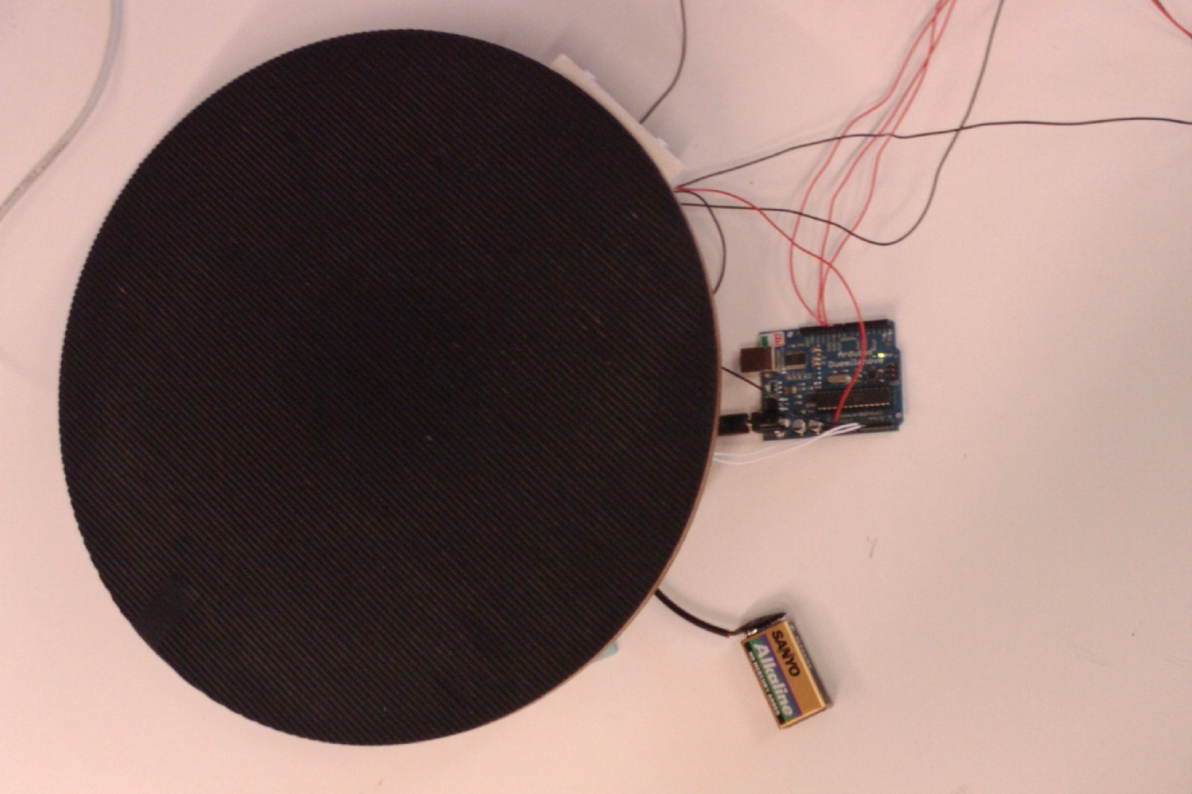

Long black wires: Ground from SSR………………………………………………

Long red wires: Control signal to SSR…………………………………………………………………………

Short white wires: Analog in from accelerometer…………………………………

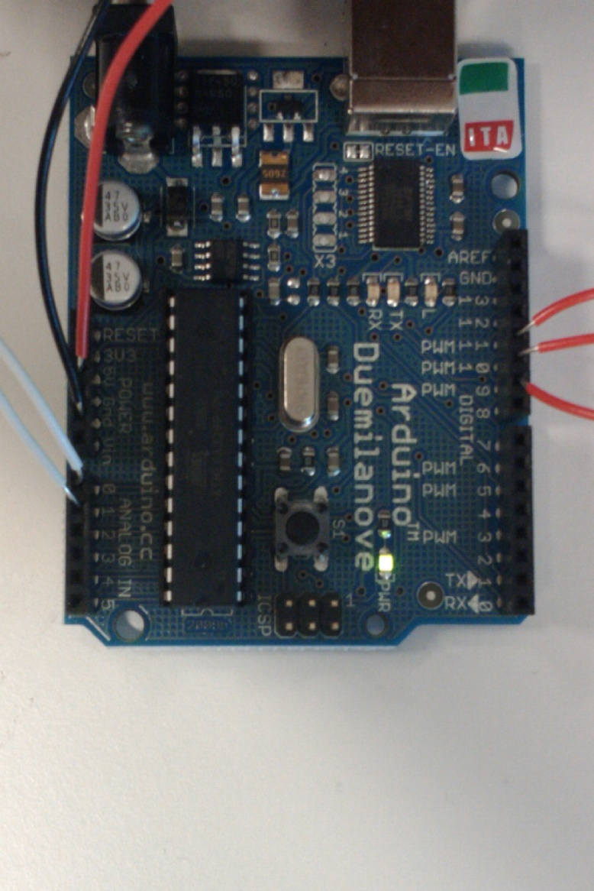

Red wires: 5V from Arduino / Power to 3D acc

Black wires: Ground from Arduino / Ground to 3D acc and SRR’s

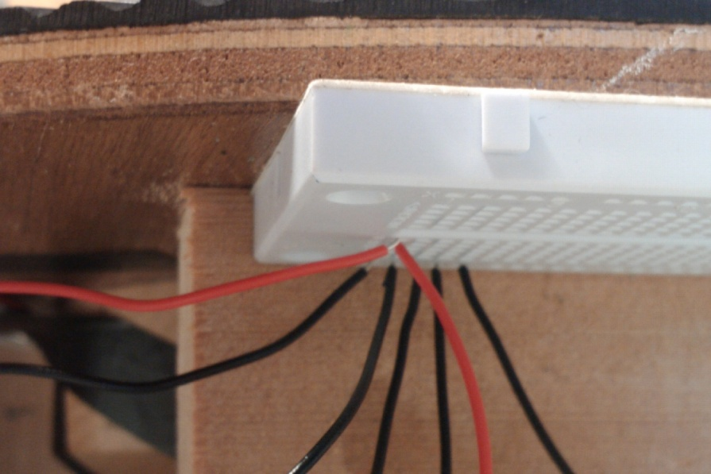

White wire: 230VAC…………………………………

Red wire: Control from Arduino

Black wire: Ground from Arduino

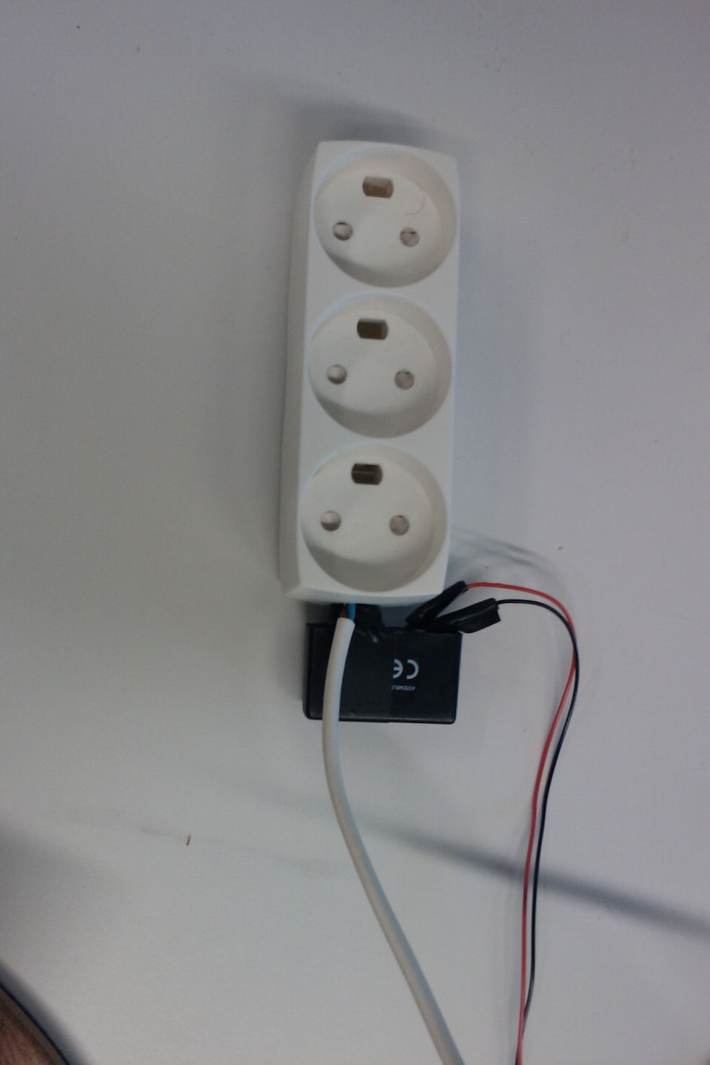

More pictures in picture folder.